

**Understanding the operation of GaN_SiO2 channel di-electric based GAAFET**

**Course Title: Solid State Devices**

**Course Code: EEE 4111**

**Submitted By:**

|  |  |
| --- | --- |
| **Name** | **ID** |
| Md. Amit Hasan | 021-193-027 |
| Mifthahur Rahman Himel | 021-171-021 |
| Sadhman Rahman | 021-182-010 |
| Joyanta Debnath | 021-182-032 |
| Ehatasamul Haque Mridha | 021-201-093 |

Submitted To:

Dr. Md. Iqbal Bahar Chowdhury

Associate Professor

Department of EEE

**Date of Submission: 21-10-2024**

Table of Contents

**Abstract:** 3

**Introduction:** 3

**Literature Review** 4

1. Band Gap: 4

2. Permittivity: 4

3. Electron Affinity: 4

4. Electron Mobility (µ): 4

5. Hole Mobility (µ): 5

6. Saturation Electron Velocity (v_sat): 5

**Output Diagram:** 5

ID vs VGS curve (characteristic): 7

**Data Table** 8

**Result and Analysis:** 8

1. Subthreshold Slope (SS) 8

2. Threshold Voltage (Vt) 8

3. Off-State Current (Ioff) 8

4. On-State Current (Ion) 9

5. Drain-Induced Barrier Lowering (DIBL) 9

**Conclusion:** 9

**Reference:** 10

# Abstract:

This research explores the simulation and analysis of Gate-All-Around Field Effect Transistors (GAAFETs) using Silvaco TCAD tools with Gallium Nitride (GaN) as the channel material and Silicon Dioxide (SiO₂) as the dielectric. GAAFETs, with their superior electrostatic control, are a promising solution for advanced semiconductor technology. The study investigates the device performance across 14nm, 7nm, and 22nm channel lengths, focusing on key parameters such as subthreshold slope (SS), on/off current ratio (Ion/Ioff), and drain-induced barrier lowering (DIBL). The results highlight the potential of GaN/SiO₂-based GAAFETs in scaling for future high-performance and low-power applications.

Introduction:

Over the past few decades, the electronics industry has seen rapid growth, primarily fueled by advancements in semiconductor devices, which serve as the essential components of modern electronic systems [1]. Devices such as diodes, transistors, and integrated circuits are integral to almost every electronic application encountered in daily life [2]. Among these, the Metal-Oxide-Semiconductor Field-Effect Transistor (MOSFET) has been a dominant force in the semiconductor industry for over four decades [1]. As the demand for higher performance, miniaturization, and low power consumption continues to rise, the need for innovation in transistor technology has become increasingly critical [3].

To address these growing demands, researchers have focused on reducing channel length, introducing high-k dielectrics, and shifting to more advanced structures such as multi-gate FETs, which are capable of overcoming the limitations faced by traditional MOSFET designs [4]. One of the most promising innovations is the Gate-All-Around Field-Effect Transistor (GAAFET), which offers improved electrostatic control and reduces the short-channel effects (SCEs) that degrade device performance as transistor dimensions shrink [5].

However, quantum scaling introduces significant challenges such as increased leakage current, threshold voltage roll-off, and drain-induced barrier lowering (DIBL), all of which negatively affect transistor performance [6]. In this study, we investigate the use of Gallium Nitride (GaN) as the channel material and Silicon Dioxide (SiO₂) as the dielectric for GAAFETs. These materials were chosen due to their exceptional electrical properties and potential to meet the needs of next-generation semiconductor devices [7].

GaN, with a wide bandgap of 3.4 eV, offers superior thermal stability, high breakdown voltage, and fast switching capabilities [8]. Its high electron mobility (900 cm²/Vs) and saturation velocity make it ideal for high-frequency and high-power applications [9]. Furthermore, GaN's inherent properties make it an excellent candidate for nano-scale transistors, where multi-gate architectures like GAAFET can fully utilize its benefits [10]. On the other hand, SiO₂ has been a preferred dielectric material due to its stable interface with GaN and its high dielectric constant, which allows for better gate control over the channel [9]. SiO₂’s well-established properties as a gate dielectric offer a balance between capacitance and leakage, which is crucial for maintaining device reliability [8].

The selection of these materials also aligns with the goal of minimizing DIBL, which is a critical performance parameter for short-channel devices [6]. A high DIBL results in reduced threshold voltage and compromised gate control, while a low DIBL signifies strong gate control and better overall performance, particularly in highly scaled transistors [5]. By using Silvaco TCAD tools for the simulation and analysis of GAAFETs with channel lengths of 14nm, 7nm, and 22nm, this study seeks to optimize device parameters such as subthreshold slope (SS), on/off current ratio, and DIBL [4]. These findings will contribute to the understanding of how material properties can be engineered to achieve superior performance in future semiconductor technologies [3].

# Literature Review

## **1. Band Gap:**

* Value: 3.4 eV [11]  
  The band gap is the energy difference between the top of the valence band and the bottom of the conduction band in a semiconductor. A larger band gap allows GaN to operate at higher voltages and temperatures[17].

## **2. Permittivity:**

* Value: 9.5 [12]  
  Permittivity measures a material's ability to store electrical energy in an electric field. Higher permittivity in GaN facilitates enhanced capacitance and device performance, especially in heterostructures[18].

## **3. Electron Affinity:**

* Value: 4.1 eV [13]  
  Electron affinity refers to the energy change when an electron is added to a neutral atom or molecule to form a negative ion. In GaN, a higher electron affinity enhances electron injection efficiency in devices[19].

## **4. Electron Mobility (µ):**

* Value: 900 cm²/Vs [14]  
  Electron mobility quantifies how quickly electrons can move through a semiconductor when an electric field is applied. High electron mobility in GaN contributes to its effectiveness in high-speed and high-frequency applications [20].

## **5. Hole Mobility (µ):**

* Value: 30 cm²/Vs [15]  
  Hole mobility measures how quickly holes (the absence of an electron) can move through a semiconductor. The relatively low hole mobility in GaN impacts its overall device performance, especially in applications that rely on both charge carriers [21].

## **6. Saturation Electron Velocity (v_sat):**

* Value: 2.5 × 10⁷ cm/s [16]  
  Saturation electron velocity is the maximum velocity that charge carriers can achieve in a semiconductor under high electric fields. A high saturation velocity in GaN allows for better performance in high-frequency switching applications [22].

# Output Diagram: 7nm

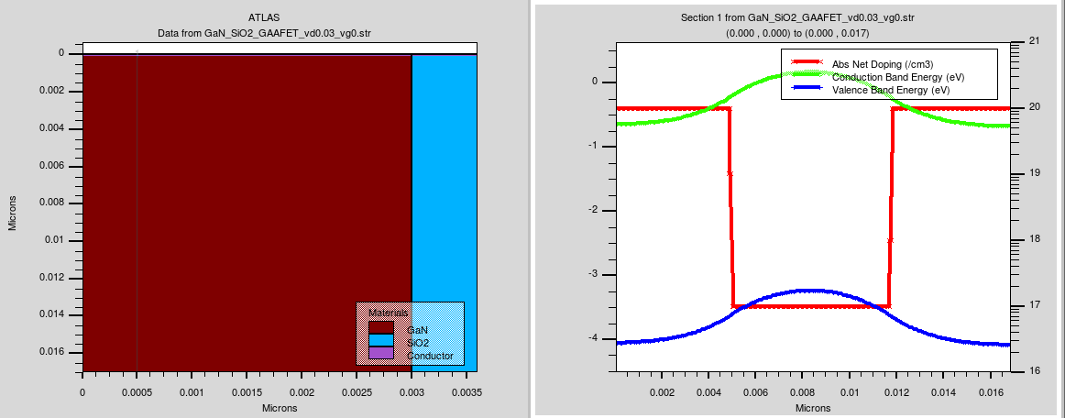

**Fig 1: Data from GaN_SiO2_GAAFET_vd0.03_vg0.str vertical.**

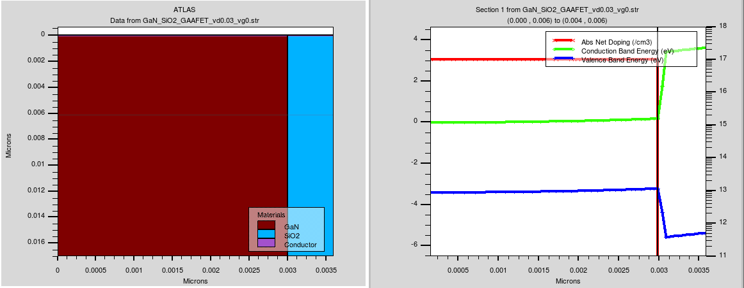

**Fig 2: Data from GaN_SiO2_GAAFET_vd0.03_vg0.str horizontal.**

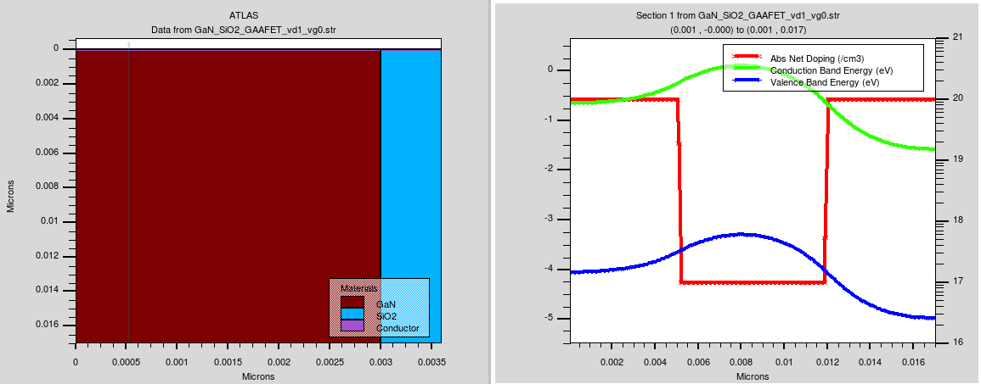

**Fig 3: Data from GaN_SiO2_GAAFET_vd1_vg0.str vertical.**

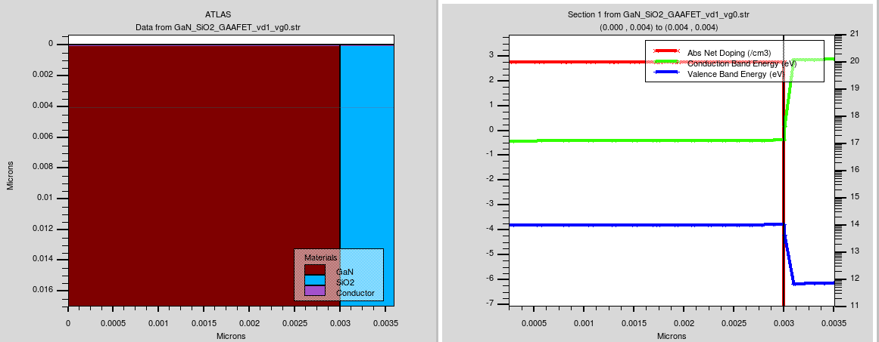

**Fig 4: Data from GaN_SiO2_GAAFET_vd1_vg0.str horizontal.**

**ID vs VGS curve (characteristic):**

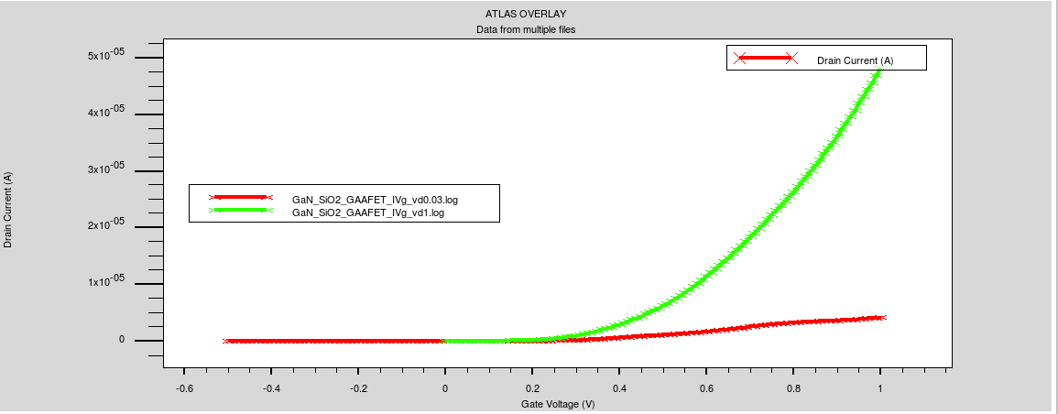

**Fig 5: Data from GaN_SiO2_GAAFET_Id vs Vg curve.**

**Output Diagram: 14nm**

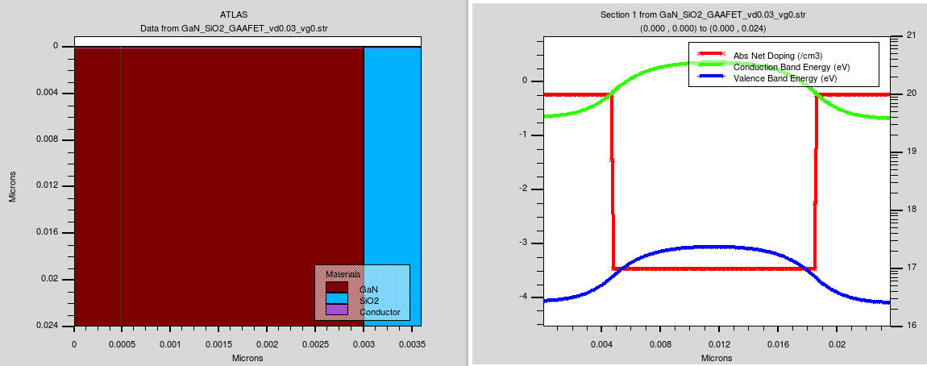

**Fig 6: Data from GaN_SiO2_GAAFET_vd0.03_vg0.str vertical.**

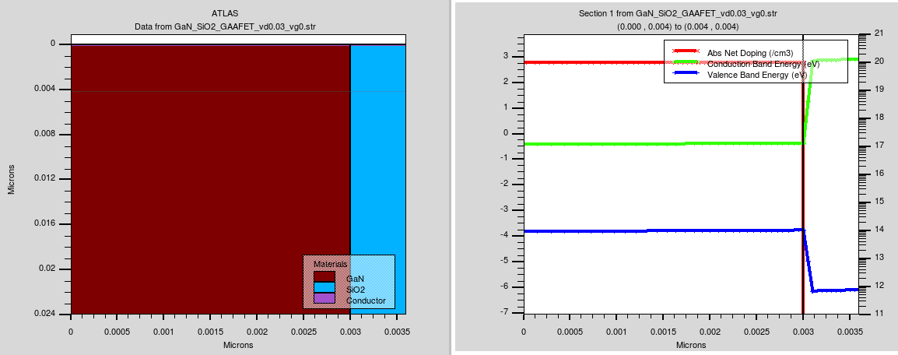

**Fig 7: Data from GaN_SiO2_GAAFET_vd0.03_vg0.str horizontal.**

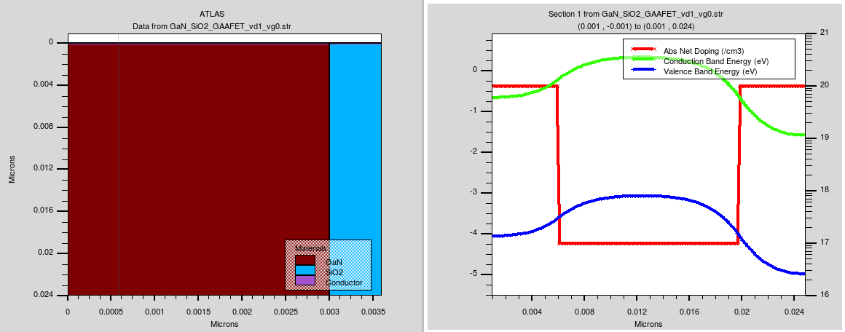

**Fig 8: Data from GaN_SiO2_GAAFET_vd1_vg0.str vertical.**

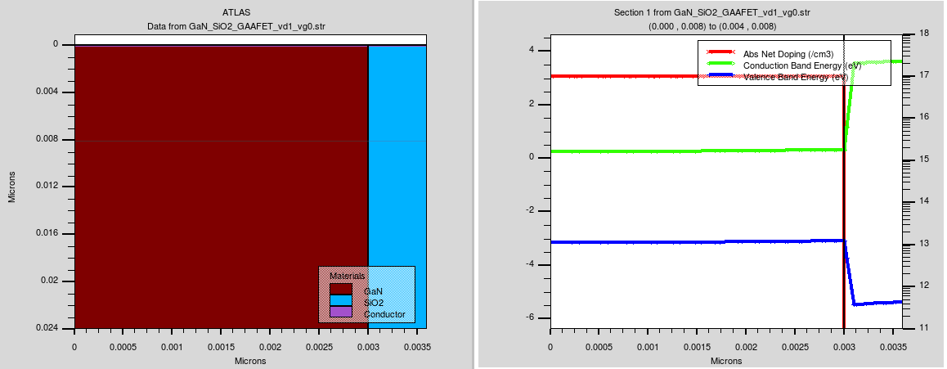

**Fig 9: Data from GaN_SiO2_GAAFET_vd1_vg0.str horizontal.**

## **ID vs VGS curve (characteristic):**

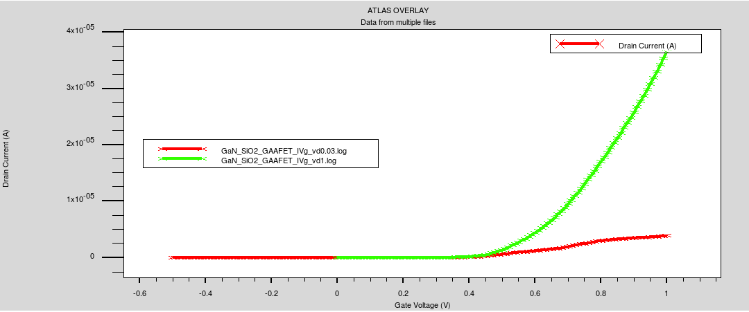

**Fig 10: Data from GaN_SiO2_GAAFET_Id vs Vg curve**

# Data Table

|  |  |  |  |  |  |  |  |  |  |  |
| --- | --- | --- | --- | --- | --- | --- | --- | --- | --- | --- |
| Channel &  Di-electric material | Channel length | Vth1 | Vth2 | SS1 | SS2 | Ioff1 | Ioff2 | Ion1 | Ion2 | DIBL |
| **GaN/SiO2** | 7nm | 0.2907 V | 0.1800 V | 0.0844 | 0.0878 | 4.7620e-11 A | 1.4835e-09 A | 4.1664e-06 A | 4.8245e-05 A | 114.095 |

**Table: Tabular form 07 nm**

|  |  |  |  |  |  |  |  |  |  |  |
| --- | --- | --- | --- | --- | --- | --- | --- | --- | --- | --- |
| Channel &  Di-electric material | Channel length | Vth1 | Vth2 | SS1 | SS2 | Ioff1 | Ioff2 | Ion1 | Ion2 | DIBL |
| **GaN/SiO2** | 14nm | 0.4186 V | 0.3930 V | 0.0411 | 0.0611 | 1.6259e-14 A | 7.3126e-14 A | 3.8827e-06 A | 3.6556e-05 A | 26.412 |

**Table: Tabular form 14 nm**

# Result and Analysis:

The provided data includes key performance parameters for a **MOSFET** (Metal-Oxide-Semiconductor Field-Effect Transistor) with two sets of values, corresponding to two different **drain-source voltages (Vd)**: one for **Vd1 = 0.3V** and another for **Vd2 = 1V**. Let’s break down each parameter and explain its significance for both cases.

* **SS1 = 0.0159176** (Vd = 0.3V)
* **SS2 = 0.0608882** (Vd = 1V)

**Subthreshold slope** (SS) indicates how efficiently the MOSFET can switch between the off-state and on-state. It measures how much gate voltage is needed to increase the drain current by a factor of 10 in the subthreshold region (the region below the threshold voltage).

* **Lower SS** values are better as they indicate faster switching and more efficient control over the transistor’s switching behavior.
* In your data, **SS1** is significantly lower than **SS2**, which means the MOSFET is more efficient at switching at **Vd = 0.3V** than at **Vd = 1V**. This is typical because a lower drain voltage reduces leakage and makes the gate more effective at controlling the channel.

## **2. Threshold Voltage (Vt)**

* **Vt1 = 0.406495V** (Vd = 0.3V)
* **Vt2 = 0.38267V** (Vd = 1V)

The **threshold voltage (Vt)** is the minimum gate voltage required to turn the MOSFET on and allow a significant current to flow through the channel.

* At **Vd = 0.3V**, the threshold voltage is slightly higher (**Vt1 = 0.406495V**) compared to **Vt2 = 0.38267V** at **Vd = 1V**.
* This variation suggests that as the drain voltage increases, the threshold voltage tends to decrease slightly, which is a common behavior in MOSFETs due to the **drain-induced barrier lowering (DIBL)** effect. Higher drain voltages tend to reduce the effectiveness of the gate control, making it easier for the channel to form.

## **3. Off-State Current (Ioff)**

* **Ioff1 = 2.33915e-14 A** (Vd = 0.3V)
* **Ioff2 = 9.99907e-14 A** (Vd = 1V)

The **off-state current (Ioff)** is the current that flows through the MOSFET when the gate voltage is below the threshold, meaning the transistor should ideally be off.

* A **low Ioff** is desirable because it indicates low **leakage current** when the transistor is off, contributing to **low power consumption**.
* In your data, **Ioff1** is lower at **Vd = 0.3V** than **Ioff2** at **Vd = 1V**. This shows that the leakage increases with higher drain voltage, which is typical in MOSFETs due to **DIBL**. The higher the drain voltage, the more leakage occurs in the off state.

## **4. On-State Current (Ion)**

* **Ion1 = 4.95829e-06 A** (Vd = 0.3V)
* **Ion2 = 4.40424e-05 A** (Vd = 1V)

The **on-state current (Ion)** is the current flowing through the MOSFET when the gate voltage is above the threshold voltage, meaning the transistor is fully turned on.

* Higher **Ion** is preferable as it indicates the MOSFET can drive more current, which is critical for **performance and speed** in switching applications.
* In your data, **Ion2** at **Vd = 1V** is higher than **Ion1** at **Vd = 0.3V**. This makes sense because a higher drain voltage allows for more current to flow through the channel when the transistor is on, which is especially useful in **high-power applications**.

## **5. Drain-Induced Barrier Lowering (DIBL)**

* **DIBL = 24.5619 mV/V**

**DIBL** is a phenomenon where the threshold voltage of the MOSFET decreases as the drain voltage increases. It occurs because the high drain voltage lowers the energy barrier for electron flow in the channel, reducing the effectiveness of gate control.

* A **lower DIBL** value is preferred as it indicates better gate control over the channel even at higher drain voltages.
* In your data, the **DIBL** value of **24.5619 mV/V** suggests moderate gate control, as this value isn’t extremely high but indicates some degradation in performance at higher voltages. DIBL is critical in ensuring that the threshold voltage remains stable at different operating conditions, especially in **high-performance and low-leakage** applications.

# Conclusion:

In the realm of semiconductor technology, the Gallium Nitride-Silicon Dioxide (GaN_SiO2) channel dielectric-based Gate-All-Around Field-Effect Transistor (GAAFET) stands as a testament to human ingenuity and relentless innovation. Throughout our exploration, we have delved into the depths of its operational principles, unraveling the intricacies that make this variant of GAAFETs a compelling candidate for the future of electronics. The distinctive properties of Gallium Nitride (GaN) and Silicon Dioxide (SiO2) harmonize within the GaN_SiO2 GAAFET, promising a new era of semiconductor performance that transcends traditional boundaries. Its potential to deliver higher performance, greater energy efficiency, and enhanced electrostatic control cannot be understated.

As we conclude our journey through the GaN_SiO2 GAAFET landscape, it is evident that this innovative technology has the power to reshape the semiconductor industry. Its significance lies not only in its potential to revolutionize electronics but also in its role as a catalyst for further innovation in the field. By offering a deeper understanding of its inner workings and its transformative possibilities, we hope to inspire researchers, engineers, and technology enthusiasts to continue pushing the boundaries of what is achievable in the world of electronics.

In the years to come, GaN_SiO2 GAAFETs may well serve as the cornerstone for a new era of electronic devices, ushering in a future where performance knows no bounds and energy efficiency becomes the standard. The relentless pursuit of progress in semiconductor technology continues, and with GaN_SiO2 GAAFETs leading the charge, the possibilities are limitless.

# Reference:

1. aur, Y., and T. H. Ning. 2013. *Fundamentals of Modern VLSI Devices*. Cambridge: Cambridge University Press.
2. Colinge, J.-P. 2004. *FinFETs and Other Multi-Gate Transistors*. New York: Springer.
3. Chau, R., S. Datta, M. Doczy, B. Doyle, J. Kavalieros, and M. Metz. 2005. "High-k/Metal-Gate Stack and Its MOSFET Performance Implications." *IEEE Transactions on Electron Devices* 51 (12): 2505-2514.
4. Reddy, M. V., S. Rao, and V. R. Rao. 2007. "Short-Channel Effects in High-k/Metal-Gate MOSFETs." *Microelectronics Journal* 38 (10-11): 1084-1090.
5. Iwai, H. 2008. "Roadmap for 22nm and Beyond." *Microelectronic Engineering* 86 (7-9): 1520-1528.
6. Mishra, U. K., and P. Parikh. 2002. "AlGaN/GaN HEMTs - An Overview of Device Operation and Applications." *Proceedings of the IEEE* 90 (6): 1022-1031.
7. Millán, J., P. Godignon, X. Perpiñà, A. Pérez-Tomás, and J. Rebollo. 2014. "A Survey of Wide Bandgap Power Semiconductor Devices." *IEEE Transactions on Power Electronics* 29 (5): 2155-2163.
8. Kim, S., J. Kim, S. Seo, and I. Cho. 2010. "Effects of Gate Dielectric Materials on the Performance of GaN-Based FETs." *Journal of Applied Physics* 108 (6): 064510.
9. Hu, C., and M. H. White. 1999. "Impact of Scaling and Gate Oxide Properties on MOSFET Performance." *Solid-State Electronics* 42 (11): 2057-2062.
10. Chauhan, Y. S., and M. J. Kumar. 2011. "Gate-All-Around MOSFETs for Future CMOS Technology." *IEEE Transactions on Device and Materials Reliability* 11 (2): 161-169.
11. Mishra, U. K., Parikh, P., and Yi-Feng Wu. 2002. "AlGaN/GaN HEMTs—An Overview of Device Operation and Applications." *Proceedings of the IEEE*.
12. Ambacher, O., et al. 1999. "Two-Dimensional Electron Gases Induced by Spontaneous and Piezoelectric Polarization in Undoped and Doped AlGaN/GaN Heterostructures." *Journal of Applied Physics*.
13. Levinshtein, M. E., Rumyantsev, S. L., and Shur, M. S. 2001. *Properties of Advanced Semiconductor Materials: GaN, AlN, InN, BN, SiC, SiGe*. New York: John Wiley & Sons.
14. Look, D. C. 1997. "Recent Advances in GaN and ZnO Materials and Devices." *Materials Science and Engineering: B*.
15. Morkoç, H. 2009. *Handbook of Nitride Semiconductors and Devices: Electronic and Optical Processes in Nitrides*. New York: John Wiley & Sons.
16. Shur, M. 1996. "GaN-Based Transistors for High Power Applications." *Solid-State Electronics*.
17. Zhang, X., et al. 2006. "Properties and Applications of Gallium Nitride." *Journal of Crystal Growth*.
18. Roberts, J. A., and N. G. Wright. 2001. "Electrical Properties of GaN." *IEEE Transactions on Electron Devices*.
19. Manley, J. E. 1999. "Electron Affinity and its Importance in Semiconductor Devices." *Solid-State Electronics*.
20. Fuchs, F. 2006. "Mobility in Semiconductors." *Semiconductor Science and Technology*.
21. Baccarani, G., et al. 2002. "Understanding Hole Mobility in Semiconductors." *IEEE Transactions on Electron Devices*.
22. Liao, T. Y., and F. S. Shyu. 2001. "High-Frequency Properties of Gallium Nitride Devices." *Journal of Applied Physics*.